# We will go over in class how to setup VirtualBox

VMware instructions below.

# Setting up a VMware Virtual Machine

In this lab we'll create a Minix virtual machine using the VMware Workstation Console.

1. Copy Minix_R3.3.iso from a thumb drive to the Desktop
2. Start VMware Workstation. Your screen may look different but the steps are the same.

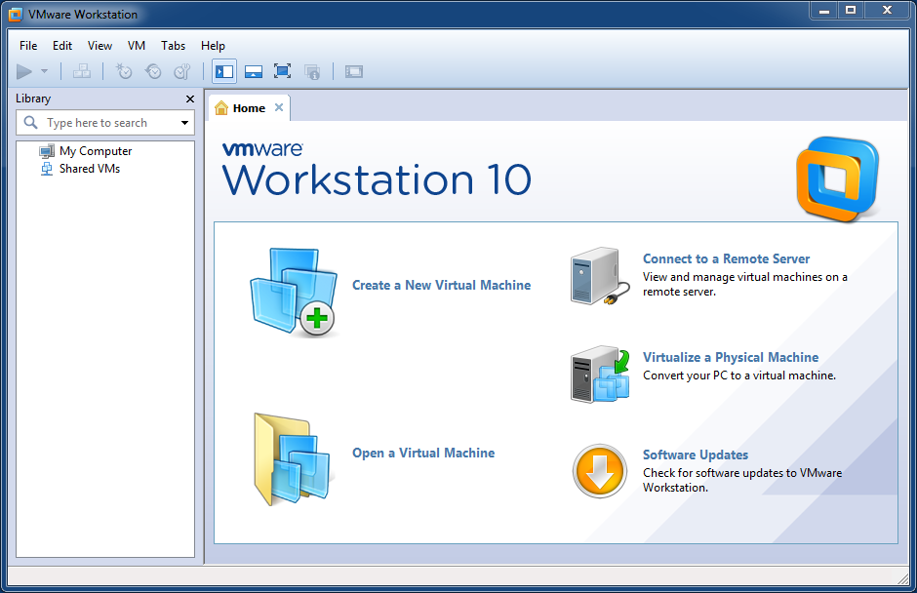

1. When starting VMware or a virtual machine, you may get a message saying that updates are available. Dismiss this dialog box if it appears.
2. Click Create a new Virtual Machine.

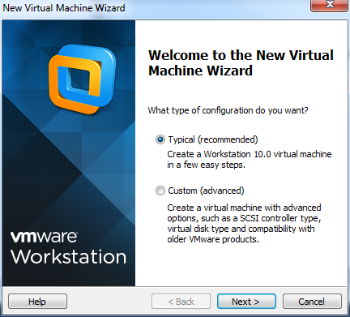

1. Click Next to use the default value of Typical.

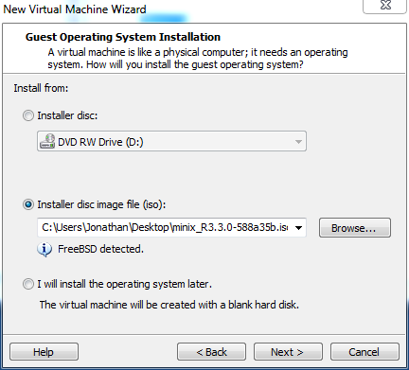

1. Choose Installer disc image file (iso). If the ISO file on the desktop is not already pre-selected, click the Browse ... button and select it then click Next

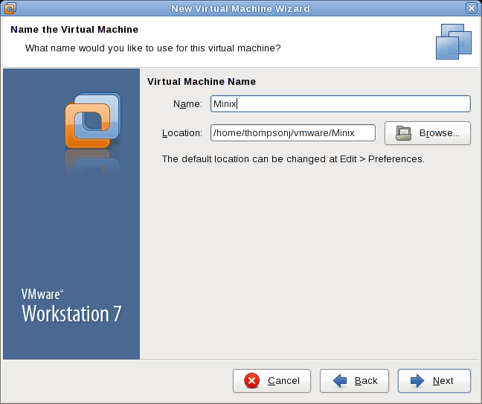

1. Change the name of the Virtual Machine from FreeBSD to Minix. If you want this virtual machine file installed in a different location than that shown, click the Browse... button and select a different folder. When you're done adjusting the location, click Next

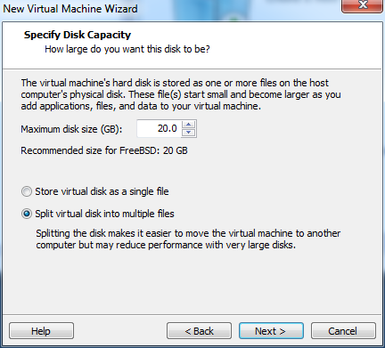

1. Use the default of 20.0 GB for the maximum disk size and click Next.

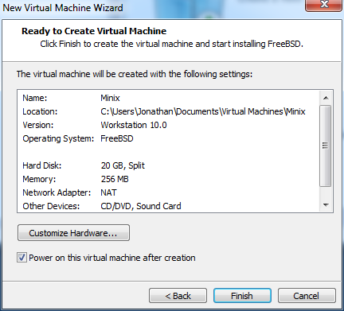

1. Click Finish.
2. The virtual machine will start and Minix will choose Boot Option 1 by default

### Minix Installation

1. Click once inside the black window so that input from the keyboard is directed to the virtual machine.
2. When the Minix login prompt appears, enter root.
3. To start the installation of MINIX, type

setup

After this (and all other commands), be sure to type <enter>. When the installation script ends a screen with a colon, type <enter> to continue.

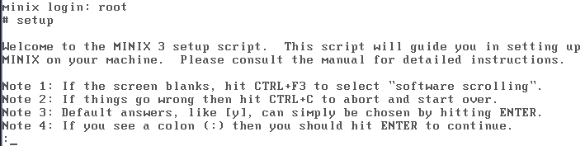

1. Be sure to follow the instructions in Note 4 above and hit <enter> to continue the setup program.
2. Keyboard type: hit ENTER to use the default of us-std
3. Create or select a partition for MINIX 3: hit enter to use automatic mode
4. Enter disk number to use: type ENTER
5. Enter region number to use: type ENTER
6. Confirm your choices by typing yes, otherwise hit <ctrl>C to exit the setup script without changing the partition table.
7. The selected partition will be divided into three subpartitions: /root, /usr, and /home. The latter is for your own personal files. Enter 128 instead of the default size for the /home directory. Acknowledge by typing ENTER.
8. Hit ENTER to use the default block size of 4KB.
9. Files will be automatically copied from the ISO file to the hard disk. Every file will be announced as it is copied. When the copying is complete, MINIX 3 is installed.
10. Type of Ethernet: type ENTER
11. Configure network using DHCP or manually? Hit ENTER to use the default (DHCP)
12. Enter shutdown now to exit MINIX. Always stop MINIX this way to avoid data loss as MINIX keeps some files on the RAM disk and only copies them back to the hard disk at shutdown time.
13. Wait until Minix displays the Done running shutdown hooks message.
14. Type <ctl>+<alt> to release the focus from the virtual machine.
15. Stop the Virtual machine by choosing VM – Power - Shut Down Guest menu option.
16. Click OK to confirm the shutdown request

### Starting and Stopping the Minix VM

1. Start the Minix VM
2. Click once in the black command window
3. At the login prompt enter root
4. The # that appears is a command prompt. To see what software programs are available, enter

ls /usr/bin | more

Press Page Down, Page Up, or Home to scroll through the list. Press End to exit.

1. To see what a particular program does, type

man program_name   
such as  
 man yacc (Yet Another C Compiler)

Press Page Down, Page Up, Home, or End to scroll through the pages. Press q to quit the man program.

1. Enter **pkgin install binutils** to install needed utility programs
2. Enter **pkgin install clang** to install the c compiler
3. Enter shutdown now to stop MINIX.
4. Type <ctl><alt> to release the focus from the virtual machine.
5. Stop the Virtual machine by choosing VM – Power - Shut Down Guest menu option.
6. Confirm the shutdown request by clicking the Shutdown button